**Go 1 Robot Leg Calibration**

1. Turn robot battery on and wait for the robot to stand up.

2. Press (L2 + A) once, then press (L2 + A) again, then press (L2 + B) to make the robot lie down.

3. Press (L1 + L2 + Start), all 3 keys at the same time.

4. Press L2 and hold, then press B three times. When you twist all four legs of the robot, you should feel no resistance in any of the legs.

5. Symmetrically close the left and right legs (front and back) above the robot without gaps at the “knees”. The legs may need to be raised up slightly to achieve this. (see attached picture for example)

6. Press (L2 + R2) and the robot’s legs will open.

7. Hold the calibration tool close to the thigh and fit it over the upper and lower part of the legs. The slightly oval side of the tool should fit into the oval part of the leg. Correct the angle of the upper and lower legs by making the legs match the angle of the calibration tool. Do this for each leg while bringing each limb straight back so that each foot sensor is touching the ground.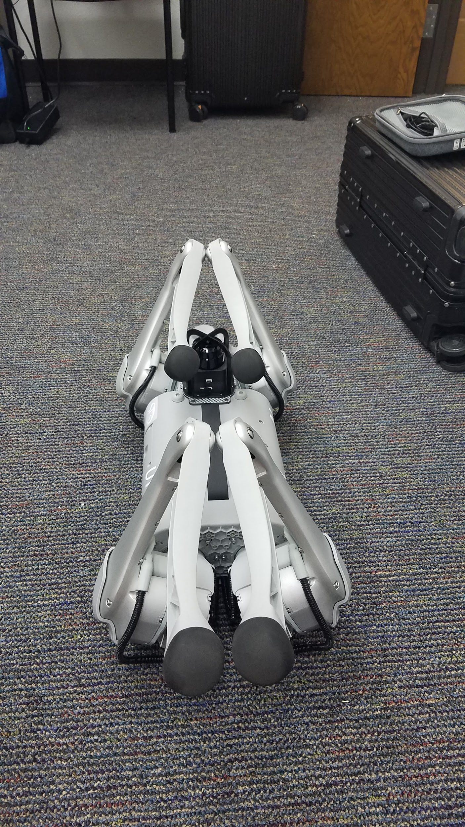

8. Press in sequence: (L1 +L2) , (L2 + R1) , (L1 + R1 + R2)

9. Turn the battery off.

10. Position the legs properly with the knees and feet touching the ground and the robot flat against the ground, then restart the battery and move the robot with the controller to check calibration. The robot should move straight ahead and not drift to the right or the left.